Three-act Structure Quiz

Syd Field, author of Screenplay and The Screen Writer's Workbook, has outlined a paradigm that most screenplays follow. A paradigm is a conceptual scheme. This paradigm is the structure that holds screenplays together. According to Field, screenplays follow a three-act structure, meaning the standard screenplay can be divided into three parts: Setup, Confrontation, and Resolution.
Act I comprises the first quarter of the screenplay. (For a two hour movie, Act I would last approximately 30 minutes.)
Act II comprises the next two quarters of the film. (For a two hour movie, Act II would last approximately 60 minutes.)
Act III comprises the final quarter of the film. (For a two hour movie, Act III would be the final 30 minutes.)
The "Plot Point"--According to Field, the three acts are separated by two plot points. A plot point, often called a reversal, is an event that thrusts the plot in a new direction, leading into a new act of the screenplay. Later screenplay gurus have built on Field's theory by stating that Plot Point #1, which leads into Act II, is the moment when the hero takes on the problem.
What Happens in Act I
Act I comprises the first quarter of the screenplay. (For a two hour movie, Act I would last approximately 30 minutes.)
What happens in Act I (Setup)?
Exposition--The part of a story that introduces the characters, shows some of their interrelationships, and places them within a time and place.
This part of the story introduces the main character, the dramatic premise, and the dramatic situation.
Main character--the person in the story who has a need/objective to fulfill and whose actions drive the story
Dramatic premise--what the story's about
Dramatic situation--the circumstances surrounding the action
Inciting Incident--an event that sets the plot of the film in motion. It occurs approximately halfway through the first act.

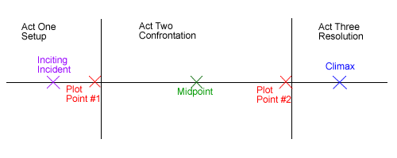
The "Plot Point"--According to Field, the three acts are separated by two plot points. A plot point, often called a reversal, is an event that thrusts the plot in a new direction, leading into a new act of the screenplay. Later screenplay gurus have built on Field's theory by stating that Plot Point #1, which leads into Act II, is the moment when the hero takes on the problem.

What Happens in Act II
Act II comprises the next two quarters of the film. (For a two hour movie, Act II would last approximately 60 minutes.)
What happens in Act II (Confrontation)?
Obstacles--In the second act, the main character encounters obstacle after obstacle that prevent him from achieving his dramatic need.
First Culmination--a point just before the halfway point of the film where the main character seems close to achieving his or her goal/objective. Then, everything falls apart, leading to the midpoint.
Midpoint--a point approximately halfway through the film where the main character reaches his/her lowest point and seems farthest from fulfilling the dramatic need or objective.
The "Plot Point"--According to Field, the three acts are separated by two plot points. A plot point, often called a reversal, is an event that thrusts the plot in a new direction, leading into a new act of the screenplay.

What Happens in Act III
Act III comprises the final quarter of the film. (For a two hour movie, Act III would be the final 30 minutes.)
What happens in Act III (Resolution)?
Climax (Second Culmination)--The point at which the plot reaches its maximum tension and the forces in opposition confront each other at a peak of physical or emotional action.
Denouement--The brief period of calm at the end of a film where a state of equilibrium returns.

